|  |
| --- |
| NSW Department of Climate Change,  **Energy, the Environment and Water**  [Project name] High Impact Partnership communication and capacity building plan |

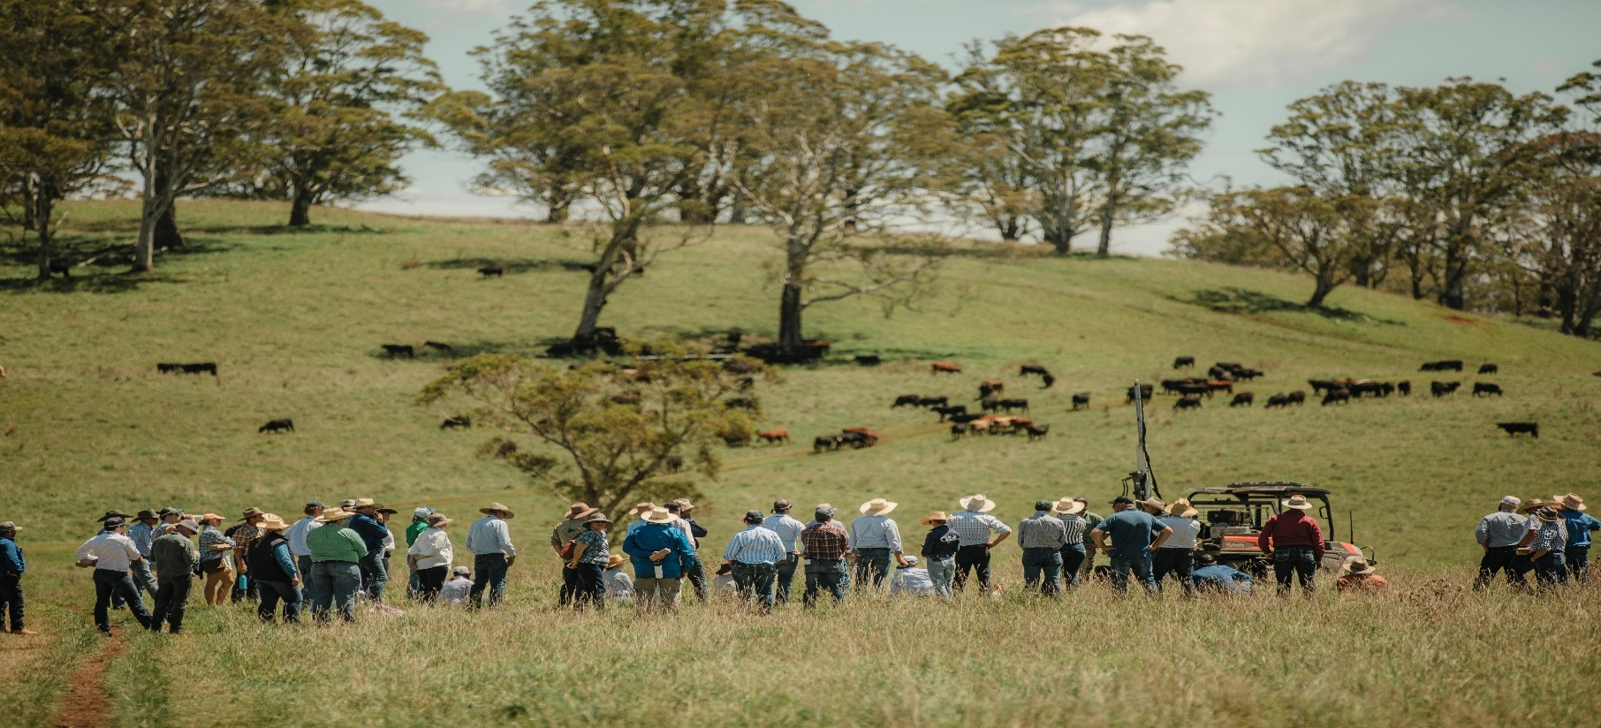

|  |
| --- |
|  |

Applicant name:



Contents

High impact partnership communication and capacity building plan 3

Introduction 3

Using this template 3

1. Project summary 5

2. Key objectives 5

3. Target audience and key messages 6

4. Communication and engagement strategy 8

5. Demonstration sites 10

6. Sharing of learnings 11

# High Impact Partnership communication and capacity building plan

## Introduction

High impact partnerships are expected to drive change in primary production and land management in NSW. They will demonstrate carbon projects integrated with farming and other land management practices. Funded projects will be required to share their learnings and outcomes to build confidence and skill in abatement activities.

The communication and capacity building plan is worth 10% of the assessment score and will be assessed against merit criterion 4 (sections 5.3 and 5.4) of the High Impact Partnership Round 2 grant guidelines.

Applicants must also, as part of this plan, indicate how they will share ongoing information and learnings beyond the project boundaries.

## What’s in this template

This template will guide you to include the following information:

* A short summary of your project.
* Key objectives of your communication and capacity building plan.
* A list of your identified target audience, such as those associated with related industries and/or land use types, their size and estimated potential capacity for carbon abatement. This should include strategies to communicate with the broader local community, where appropriate.
* Key messages that will be communicated to your target audiences and approaches to ensure those messages create behaviour change.
* A communication and engagement strategy for your target audiences outlining proposed activities, expected reach, and project influence, both during the period of the funded project and beyond to at least 2030.
* Timing and scale of the implementation of specific information delivery types such as case studies, fact sheets, video stories, social media, newsletters, demonstration sites, training days, webinars, trials of innovative methods, and how they are integrated into a capacity building program.
* Rationale for how the capacity building plan builds ongoing learning and development for participants and a description of how the project will review and develop engagement activities over time.

## 1. Project summary

Provide a short summary of your project. You can copy and paste the brief description from your application form.

## 2. Key objectives

Describe the key objectives of your communication and capacity building plan.

## 3. Target audience and key messages

List your identified target audiences. Consider those associated with related industries and/or land use types, their size, and estimated potential capacity for carbon abatement. Outline your key messages for each audience, and your approach to ensure those messages create behaviour change. This could include strategies to communicate with the broader local community.

|  |  |  |
| --- | --- | --- |
| **Audience** | **Key messages** | **Approach** |
| Local farmers and land managers | There are relevant resources available to help people assess the potential for a carbon project on their land | Promote the project website resources and links, then run workshops and 1:1 property visits to help landholders apply the tools |
|  |  |  |
|  |  |  |
|  |  |  |
|  |  |  |
|  |  |  |
|  |  |  |

## 4. Communication and engagement strategy

Outline your proposed communication and engagement activities. You must include your approach for activities during and beyond the funded project period, to at least 2030. Possible activities include case studies, fact sheets, video stories, social media posts, newsletters, demonstration sites, training days, webinars, trials of innovative methods. Note: Your activities listed in this table must also be reflected in your Outcomes table in the application form as part of the deliverables for your project.

See example in the first row. You can add more rows if you have more activities to add.

|  |  |  |  |
| --- | --- | --- | --- |
| **Activity** | **Audience** | **Communication method** | **Frequency** |
| Deliver webinar about how to design a carbon project | Local landholders and the wider community | Online webinar. Use social media to promote. | Once before the end of year 1 |
|  |  |  |  |
|  |  |  |  |
|  |  |  |  |
|  |  |  |  |
|  |  |  |  |
|  |  |  |  |
|  |  |  |  |
|  |  |  |  |
|  |  |  |  |
|  |  |  |  |
|  |  |  |  |
|  |  |  |  |
|  |  |  |  |
|  |  |  |  |

## 5. Demonstration sites

You must commit to showcasing at least one of your implementation sites with the aim of building awareness, knowledge, and confidence around carbon projects. This is called a ‘demonstration site’ and can be used for engagement, learning, and development for other land managers.

These sites will enable land managers to better understand the context, process and implications of developing a carbon project on their land. Tangible, real-time examples are an optimal way for landholders to see ‘what’s possible’, and understand some of the realities including costs, management tasks, risks, and benefits.

Demonstration sites may include online case studies and videos detailing actions at a specific site, not just physical site access.

Please describe how you will use one or more of your project sites as a demonstration site for other land managers. Refer to section 5.4 of the grant guidelines for examples of demonstration sites you could develop.

## 6. Sharing of learnings

Describe how your project will share on-going learnings and information with your audience and stakeholders. Focus on learnings related to project delivery, abatement, and co-benefits.

Describe how your project will develop, review, and adapt engagement activities over time, including beyond the lifetime of the High Impact Partnership grant.