Living Carbon Grants

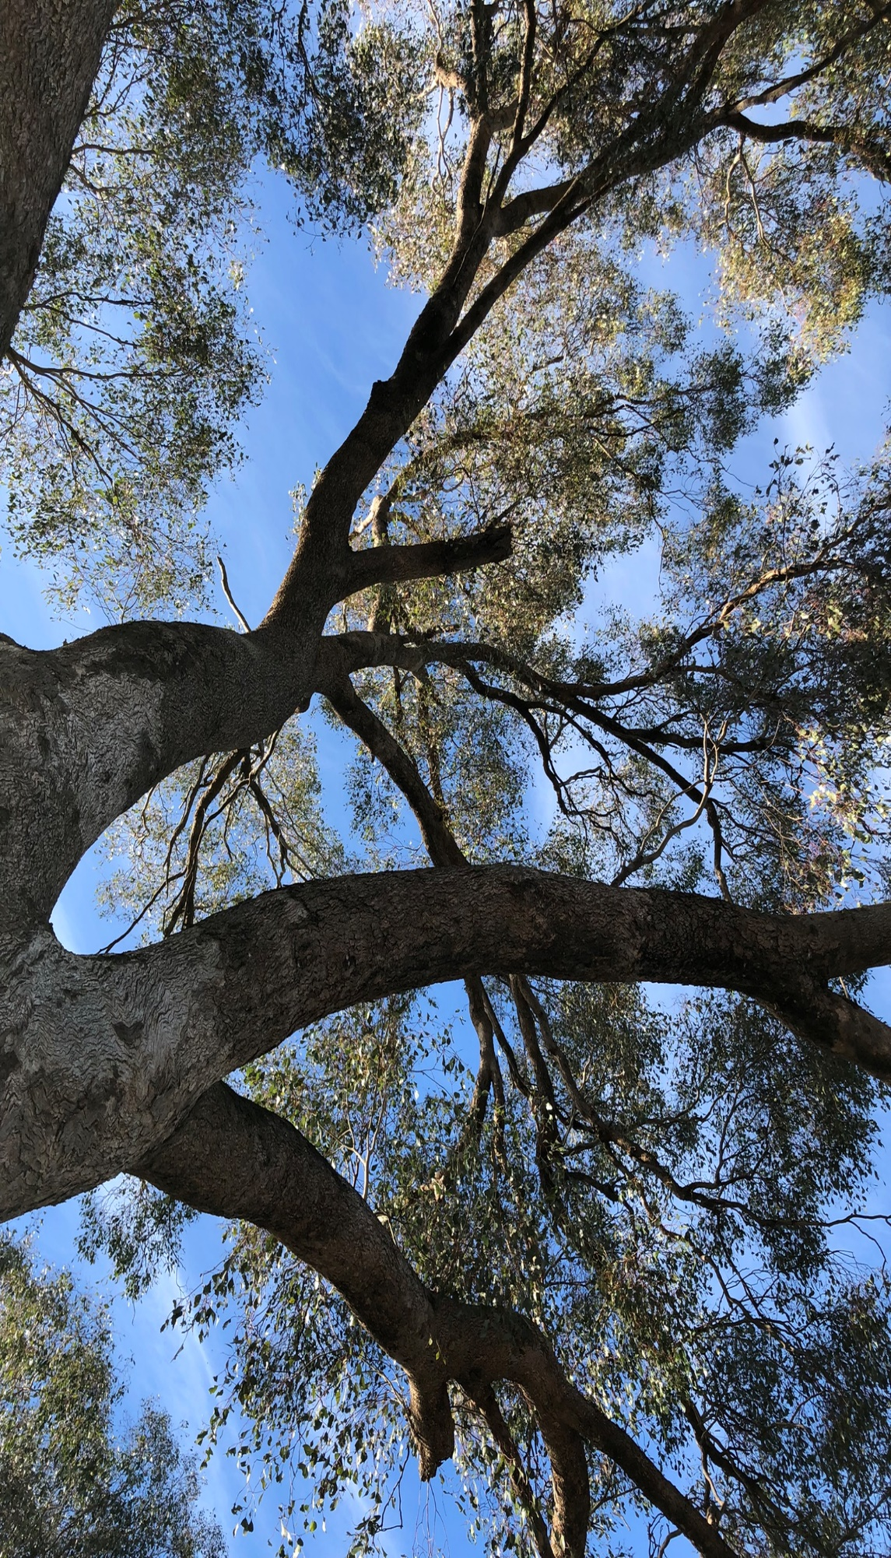
Planting Plan

For: (Property name)

Date completed: (enter date)

Date completed: (enter date)

Date completed: (enter date)

Date completed: (enter date)

Date completed: (enter date)

Date completed: (enter date)

Date completed: (enter date)

Date completed: (enter date)

Date completed: (enter date)

Date completed: (enter date)

Date completed: (enter date)

Date completed: (enter date)

Date completed: (enter date)

Date completed: (enter date)

Date completed: (enter date)

Date completed: (enter date)

Date completed: (enter date)
(You may delete this page from your completed plan.)
Using the plan
As part of your Living Carbon grant application, you are required to submit a completed planting plan that is endorsed by the on-ground support partner for the region your project is located in.
You should refer to the planting plan for your region when completing your planting plan. A planting plan guide for each region is available on our website. We recommend that you fill out each table in the planting plan workbook first (see section 1.2 of the guide), then copy and paste the completed tables into your planting plan. When you do this, be careful to paste the contents only – without the formulas.
Do this by:
- selecting/highlighting the completed table in the workbook
- right click and select ‘Copy’
- go your planting plan, place the cursor where you want to paste/insert the table and right click on it,
- select “Paste Special”
- select the first icon on the left to “Keep Source Formatting (K)”( )

This version of the Planting plan template is provided as of April 2024.

Contents
1 About this planting plan 4
2 Property information 5
2.1 Property 5
2.2 Local landscape 5
2.3 Landscape map 6
3 Carbon revegetation project 7
3.1 Registered carbon project 7
3.2 Living Carbon project 7
3.3 Planting map 9
4 Project activities 11
4.1 Revegetation method 11
4.2 Site preparation 11
4.3 Fencing 12
4.4 Tree protection 12
4.5 Monitoring and maintenance 13
5 Target co-benefits 14
5.1 Target co-benefits 14
5.2 Biodiversity map 15
5.3 Species diversity and abundance to be planted 16
6 Environmental accounting 18
6.1 Designing your environmental account 18
6.2 Specific method requirements 18
7 Project delivery 19
7.1 Timing considerations 19
7.2 Project schedule for 18 months of the Living Carbon grant 20
7.3 Project schedule for 1 to 5 years 21
7.4 Project schedule for 6 to 25 years 22
8 Budget and Contractors 23
8.1 Budget 23
8.2 Nominating contractors 24
9 Landholder commitment and on-ground support partner endorsement 25

About this planting plan
This planting plan has been developed to meet the requirements of the NSW Government’s Living Carbon grant program. It is guided by the planting plan guide for [write region name] from the grant website.
This plan sets out the proposed 2024 planting project at [property name] aimed at storing carbon and improving biodiversity.
You may add other details or photos relevant to your project.

☐ (Check box) I have checked that I am using the correct guide for my region.

Property information
This section captures the basic information about your property and the planting project location within the surrounding landscape.
Name of owner (and name of property manager if applicable)
Address ​of the property your project is located on
Property area (hectares)
Enterprise(s) occurring on the property (If you have owned the property for less than 5 years, list land use/enterprise prior to ownership)
Year the current landholders came into ownership of the property
Natural Resource Management (NRM) (Local Land Services) Region

Property

Local landscape
Average annual rainfall (mm) ​
Soil type(s) on the property
Nearest remnant, existing or regenerated native vegetation on the property, and adjacent land that your project could connect to (show on the Landscape map)
Key natural features (waterbodies, elevated areas, rocky outcrops, unique ecosystems, etc.)

Landscape map
Insert a copy/image of your Landscape map and a brief description of what it shows. Section 2.3 of the planting plan guide has details of what to include in this map and an example map.
The map contains:

Insert map here

Carbon revegetation project
Record information about your registered carbon project and the planting sites in your Living Carbon project.

Registered carbon project
ACCU Scheme Project ID:
ACCU Scheme Project name: ​
Total carbon estimation area (ha):
​
Total area of the CEA that will be part of the Living Carbon project (ha):
Project description (in simple English):

Living Carbon project
Record an overview of your Living Carbon project by completing Table A below. Refer to Tables 3a and 3b in section 3 of the guide for information about the necessary requirements of the Environmental Planting Pilot method and the Living Carbon grants, including regional specifications. There is a worked example of Table A in section 3.2 of the guide showing how to fill in this table.
Table A: Planting sites and properties/characteristics
Planting site | Area (ha) | Stems per ha | Target canopy % | Plant community type(s) (PCTs) | Description
Total | 0

Complete the check list and fill in the information below to demonstrate that your project aligns with regional specifications for planting projects in your region, outlined in Table 3b of the planting guide. See Figure 2 in the guide for an example of how to fill this out.

☐ The smallest planting CEA for the Living Carbon project is ___ ha.
☐ All planting sites/CEAs have a species composition with a minimum of ___ trees and ___ shrubs being planted. The species composition of all sites combined is in Table I.
☐ All planting sites have a planting density of ___ stems or more, per the regional requirements.
☐ Seed and tubestock will be purchased from local suppliers. To ensure local provenance, only seeds or tubestock generated from seeds collected within ___km radius will be planted.

Planting map
Insert a copy/image of your Planting map and a brief description of what it shows. Section 3.3 of the planting plan guide has details of what to include in this map and an example map to help you with this task.
The map contains:

Insert map here

Project activities
Record information about your project’s revegetation methods, site preparation needed, any fencing and tree protection requirements, monitoring and maintenance. If the same information applies to multiple plantings sites, you can combine them on one line/row in the table, each site does not need its own line. Add extra rows if needed.

Revegetation method
Complete Table B below, with details about which revegetation method you will use for your planting site(s) and how many plants will be allocated to individual sites and/or revegetation methods.
Table B: Revegetation method(s) of your Living Carbon project
Revegetation method | Planting site(s) | Number of stems | Description and reasons
Total | N/A |  | N/A

Site preparation
Provide information about what you will need to do to prepare sites for your planting project in Table C below. In the description of the activity, please demonstrate that you have considered and applied the regional specifications for site preparation for revegetation and biodiversity projects in your region.
Table C: Site preparation activities of the project
Site preparation activity | Planting site(s) | Length (m) or area (ha) | Description and reasons

Fencing
If your project requires fencing materials and/or labour, please complete this section.
Provide information in Table D about the type of fencing you plan to install or repair, where it will be located (around which planting site(s)) and the reasons. In the description of the activity, please demonstrate that you have considered and applied the regional specifications for fencing for revegetation and biodiversity projects in your region (Table 4b in the guide).
Table D: Fencing materials and labour
Materials or labour | Planting site(s) | Length (m) | Description and reason

Tree protection
If your project requires tree protection materials or labour, please complete this section.
In Table E please provide information and details about the type and quantity of plant protection, materials and labour your project needs. Include information that demonstrates your project aligns with the specifications for revegetation and biodiversity projects in your region. Details of these specifications are in the guide.
Table E: Tree protection materials and labour
Tree protection materials / labour | Planting site(s) | Description and reasons (include quantity)

Monitoring and maintenance
Provide information in Table F to demonstrate that maintenance and monitoring requirements of your project align with the specifications for revegetation and biodiversity projects in your region. Details of these specification are in the guide.
Table F: Maintenance and monitoring of planting project
Maintenance and monitoring | Planting site(s) | Description and reasons

Target co-benefits
Record and plan how your revegetation carbon project will deliver biodiversity co-benefits. We expect applicants to plan their project to deliver co-benefits to a minimum of one flora species, fauna species or threatened ecological community. See section 6.3, merit assessment of the Living Carbon grant guidelines for more information.
Note: When copying and pasting tables from the workbook into your planting plan, only copy over the contents and not the formulas. Do this by following the instructions on page 2.

Target co-benefits
In Table G, list the targeted iconic species, threatened species or threatened ecological community(s) (TEC) that will benefit from your planting project.
Table G: Targeted biodiversity co-benefits your project aims to achieve and justification
Type (flora, fauna, TEC) | Common name | Scientific name | Status | Justification

Biodiversity map
Insert a copy/image of your Biodiversity map and a brief description of what it shows. Section 5.2 of the planting plan guide has details of what to include in this map and an example map.
The map contains:
Insert map here

Species diversity and abundance to be planted
Complete Table H, listing the species you intend to plant, their type (shrub or tree) and how many of each species you will be planting. If you are using the planting plan workbook, Table I will fill in automatically as you complete Table H. You can then copy and paste Table I from your workbook into your planting plan making sure to only paste the values and not the formulas. Instructions on how to do this are on page 2.
If you choose not to use the workbook and complete Table H manually, then you will also need to complete Table I by following the instructions in section 5.3 of the guide.
Table H: Species list, diversity and abundance of species planned to be planted
# | Flora species (scientific name) | Type (T, S)* | Quantity to be planted | Target species or community benefited^
1
2
3
4
5
6
7
8
9
10
11
12
13
14
15
16
17
18
*Type: T for Tree, S for shrub
^ Only complete if there is a direct relationship to a planned co-benefit

Table I: Summary of the planting project’s species diversity, abundance and co-benefits.
This table shows (1) species diversity to be planted by type, in other words how many different tree and shrub species are listed in Table H, and (2) species abundance, that is, how many of each type are being planted, and (3) how many species and plants will deliver a co-benefit.
Plant type | Total type | Quantity to be planted | % of total quantity
Trees
Shrubs
Total
Providing a direct biodiversity co-benefit

Environmental accounting

Designing your environmental account
Complete the information below about the environmental asset account(s) that you will register under an Environmental Account with Accounting for Nature (AfN). Note that a lot of information related to the design of your Environmental Account is captured in other sections of your planting plan, as outlined in Table 6a in section 6.1 of the guide. Refer to Table 6b in the guide for a list of methods you can choose from and information about licensed methods.

Chosen Environmental Assets (“Assets”), method(s) and accuracy level
Environmental Asset Account 1:
Asset class: Choose an Asset class
Environmental Asset:
Sub-Asset(s):
Depending on your chosen method, your Asset Account may have sub-assets. If you know what these are, you can list them below. Not all methods and Assets lend themselves to sub-assets.
Method and Accuracy:
Applicable planting areas:
Repeat information above if you plan to register a second Environmental Asset Account

Specific method requirements
Use the text box below to record information for your future reference about specific requirements of method(s) you have chosen. This will not be checked and does not impact your application.

Project delivery
This section records three timelines or activity schedules that you will follow when implementing your project:
            - Activity schedule specifically for Living Carbon grants (18 months)
            - Activity schedule for the first 5 years, including overlap with your Living Carbon grant
            - Long-term project and Environmental Account maintenance (6 – 25 years)
The information in section 4 Project activities and Table J below should be reflected in all three timelines.

Timing considerations
Fill in the table below using any recommendations in section 7.1 of your region’s planting plan guide.
Table J: Environmental thresholds for revegetation projects in the region
Site factor | Threshold level
Most appropriate season for revegetation
Preferred soil moisture levels
Unexpected events that may change revegetation schedule

Project schedule for 18 months of the Living Carbon grant
Create an 18-month schedule for your Living Carbon project. You can use the outline below or your preferred format. The planting plan workbook includes a worksheet called 7_Time0to18months that you may find useful.
Table K: Project schedule for 18 months of the Living Carbon grant period
Month number > | 1 | 2 | 3 | 4 | 5 | 6 | 7 | 8 | 9 | 10 | 11 | 12 | 13 | 14 | 15 | 16 | 17 | 18
Actual months >
Revegetation tasks
Order materials, order plants, book contractors
Site preparation activities (add your activities on separate rows)
Fencing activities (add your activities on separate rows)
Planting activities (add your activities on separate rows)
Maintenance and monitoring activities (add activities)
Carbon and Environmental Accounting
Annual submission to ACCU Scheme + ACCUs issued
(If applicable) Contact method owner if using NV-07 and NV-10
Register Environmental Account (EA) with AfN (Step 2 AfN)
Build Environmental Account (Step 3 AfN)
Certify Environmental Account (Step 4 AfN) (includes audit)
Biodiversity survey/ ecological assessment monitoring |  | B
EA annual certification compliance report and registration
Living Carbon grant admin
Set up monitoring points, budgeting and grant tracking
Complete project case study
Living Carbon surveys |  | 1 |  |  |  |  |  |  |  |  |  |  |  |  |  | 2
Living Carbon grant reports |  | 1 |  |  |  | 2 |  |  |  |  |  | 3 |  |  |  |  |  | 4
Monitor and report on stem survival rate 3-6 months after planting
Baseline data for environmental account certification

Project schedule for 1 to 5 years
Table L: Project schedule for 1 to 5 years
Monitoring Year 1 - 5 | Year 1 – (year) |  |  |  | Year 2 - (year) |  |  |  | Year 3 -(year) |  |  |  | Year 4 - (year) |  |  |  | Year 5 - (year)
Quarter | 1 | 2 | 3 | 4 | 1 | 2 | 3 | 4 | 1 | 2 | 3 | 4 | 1 | 2 | 3 | 4 | 1 | 2 | 3 | 4
Revegetation Activities
Monitoring activities
Carbon and Environmental Accounting admin
CER reporting, ACCUs issued (as frequently as 6 months to 5 years)
Environmental Account (EA) certification compliance report and registration (annual)
Maintain EA every 5 years or less (data collection, audit, certify)
Threat monitoring | Dependent on the site characteristics, and budget. It can be undertaken at any time.

Project schedule for 6 to 25 years
Table M: Project schedule for 6 to 25 years
Monitoring - Years 6-25 | 6 | 7 | 8 | 9 | 10 | 11 | 12 | 13 | 14 | 15 | 16 | 17 | 18 | 19 | 20 | 21 | 22 | 23 | 24 | 25
Add dates or years to this line >
Plant survival (all plants)
CER reporting, ACCUs issued (as frequently as 6 months to 5 years)
Environmental Account (EA) certification compliance report and registration (annual)
Maintain EA every 5 years or less (data collection, audit, certify)
Threat monitoring | Dependent on the site characteristics, and budget. It can be undertaken at any time, recommended annually at the same as performance monitoring.

Budget and Contractors

Budget
Enter your budget in the table below, or copy and paste it from your workbook.
Table N: Planting plan budget
Project stage | Activity Costs | Grant funding | Landowner cash co-contribution | Landowner In-kind | Third party contribution | Total Cost
Site preparation | Soil preparation
 | Weed control
Fencing | Fencing materials
 | Fencing labour
Revegetation | Direct seeding (seeds and direct seeding)
 | Tube stock
 | Tree protection materials
 | Planting labour (including augering, installation of tree guards etc.)
Maintenance and Report | Initial maintenance as per plan
 | Initial monitoring and report
Admin | ACCU Scheme and Accounting for Nature
 | Other
 | Sub total
 | Budget total

Nominating contractors
You can keep information about your chosen contractors for your own reference in the workbook in sheet 0_Contractors. Provide quotes and attach them to your grant application form in SmartyGrants.

Landholder commitment and on-ground support partner endorsement

Landowner commitment
This plan accurately describes an achievable planting project to deliver significant carbon and biodiversity outcomes, and (if supported by the Living Carbon grants program) sufficient resources will be provided to properly implement and maintain an area of high-quality revegetation.

Signature |  | Date
Name |  | Position / Business

On-ground support partner endorsement
I have inspected the planting site(s) and broader landscape described in this plan and confirm that the plan is accurate. It includes reasonable activities and budget, meets the requirements of the Living Carbon grant guidelines, and if properly implemented and maintained should deliver significant carbon and biodiversity benefits.

Signature |  | Date
Name |  | Position
Organisation

Net Zero Plan

