Net zero community emissions strategy template for NSW councils |  | - Office of Energy  and Climate Change
 |  | energy.nsw.gov.au

Contents

1 Welcome 3
2 How to use this Template 4
3 Template for a net zero community emissions strategy 6
3.1 Cover page 6
3.2 Acknowledgement of Country 7
3.3 Table of contents 8
3.4 Mayor/CEO/Councillor’s message 9
3.5 Executive summary 11
3.6 Context 12
4 Insight 15
4.1 Emissions sources and targets 15
5 Target 19
5.1 Rationale for targets 19
6 Strategy 21
6.1 Strategic priorities 21
7 Action 25
7.1 Actions 25
8 Monitoring and evaluation 27
8.1 Monitoring and evaluation 27
8.2 Glossary 29
8.3 Appendices 31

- Welcome
1
This Net zero community emissions strategy template (Template) has been developed to help NSW local government practitioners, officers and managers to develop a net zero emissions strategy or climate action plan for their communities.
This Template forms part of the Net zero community emissions guide for NSW councils (the Guide) developed as part of the NSW Government’s Net Zero Plan Stage 1 2020-2030. The Net Zero Plan is the foundation for NSW’s action on climate change, with a goal to reach net zero emissions by 2050.
Reaching net zero emissions will require local governments to play a key role as leaders and place makers through their connection to local communities. The efforts of NSW communities will be an important part of this process.
2

- How to use
this Template
The structure of this Template is based on the essential elements of a net zero community emissions strategy. While there is no set way to create a net zero community emissions strategy, this Template includes some of the important sections you can consider including when preparing your own. Take what you want from this Template and make it work for your council. Your own strategy’s length, ambition and level of commitment will be place-specific and will depend on available resources and your current progress on your net zero emissions journey.
We encourage you to investigate the work of other councils. There are many brilliant examples of net zero community emissions strategies and climate action plans available. Read, explore, engage, consult, and take notes of ideas that might work for your council.

Throughout this template you will see boxes like this, which point to ‘Essential Reading’. These are key resources that will help you to develop your strategy.
These teal sections of text or blank tables are included
in this Template as content that you can copy and paste straight into your strategy to personalise for your unique circumstances. 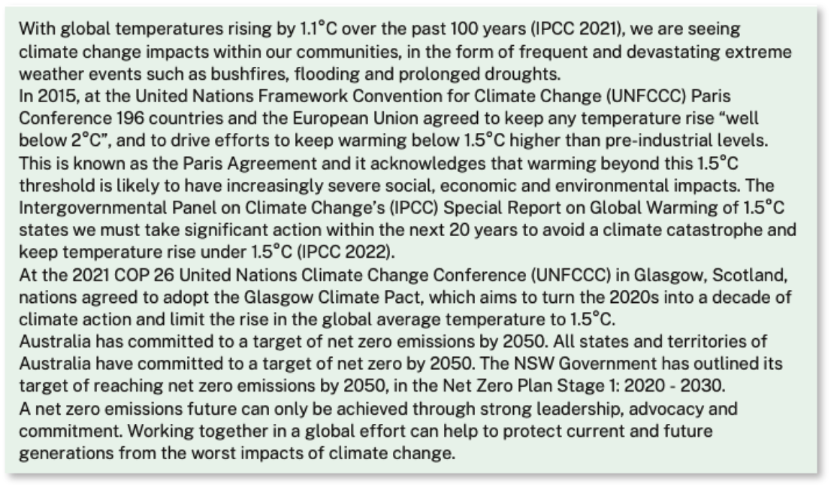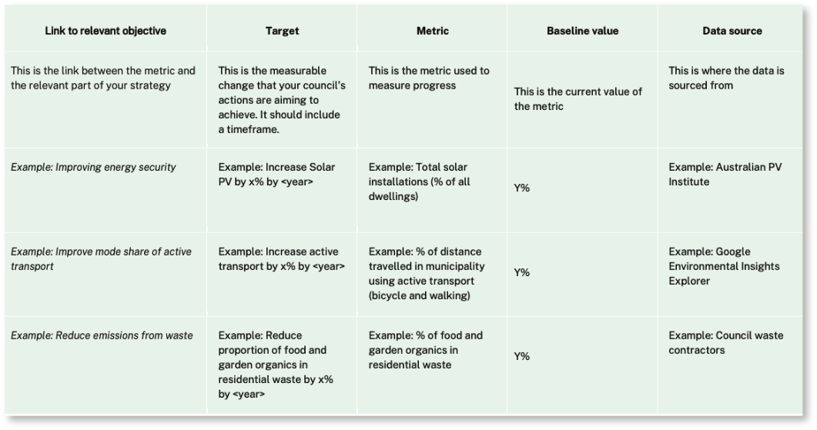
Image shows content that you can copy and paste straight into your strategy:
This practical Template takes you through the steps involved in creating a net zero community emissions strategy. Where this Template aligns with the steps in the Net zero community emissions guide for NSW councils (the Guide), you will see the following symbols:

 | 1: Insight  Gain an understanding of your community emissions and how to reduce them. |  |  | 4: Action  Detail the specific actions council will undertake to reduce emissions.
 | 2: Target  Build on insights to set targets for emissions reduction. |  |  | 5: Monitoring and evaluation  Assess and celebrate progress.
3: Strategy
Consider how your council will use its influence and resources to meet its targets.

This icon indicates the Things to consider sections of this Template, which offer checklists of elements you may consider for each section of your strategy.

This icon indicates Essential reading. For example:

Net zero emissions guide for NSW councils (Guide): This Template is intended to be used alongside the Guide which will help you to navigate the key steps involved in developing a community net zero emissions strategy.

Climate Change Integrated Planning and Reporting (IP&R) Package – by Hunter Joint Organisation: The Hunter JO Climate Change IP&R Package has clear guidance on the way local councils can embed climate change resilience within their Community Strategic Plans. The Package supports councils on their climate change journey, and provides user-friendly, practical tools and templates for councils to embed climate change as “business as usual”, by aligning activities with their IP&R framework and timelines.

- Template for
a net zero community emissions strategy
3
  - Cover page

A well designed, clear cover page introduces your reader to the strategy. The title of your strategy will depend on your local context: choose something that will resonate with your councillors and your community. Some examples of strategy names are:
- Byron Shire Council Climate Change Adaptation Plan
- Hawkesbury City Council Net Zero Emissions + Water Efficiency Strategy
- Ku-Ring-Gai Towards Zero Emissions 2030 Action Plan
- Clarence Valley Council Community Energy and Emissions Reduction Strategy
- Queanbeyan-Palerang Regional Council Climate Change Action Plan: Community Plan Period: 2020 to 2030.
Example cover pages from Hawkesbury City Council and Byron Shire Council (below) show how to keep it simple and effective, with clear title text, local imagery and council logos.
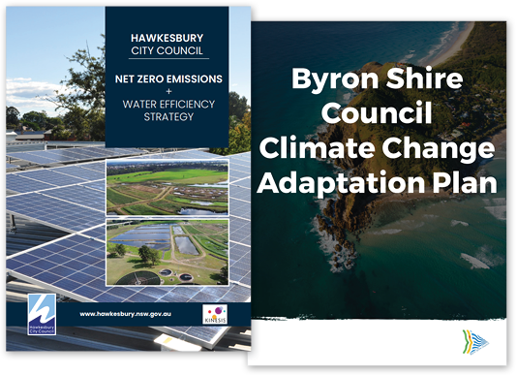

Things to consider
Is the layout simple and the text of a readable font size?
Are you using local photos or images – whether that is of council buildings or other iconic sites – that immediately place the reader in the context of your local community?
Have you included your council’s logo?
Have you framed your strategy in a way that will appeal to your councillors and local community?

  - Acknowledgement of Country
Recognising Traditional Owners in your strategy through an Acknowledgment of Country shows respect and affirms your council’s commitment to diversity and inclusion.
You may wish to include one of the following in your strategy:
<Council Name> acknowledges the < …………….. people / Traditional Owners > of the land where we work and live. We celebrate the diversity of Aboriginal peoples and their ongoing cultures and connections to the lands and waters of NSW. We pay our respects to Elders past, present and emerging, and acknowledge the Aboriginal and Torres Strait Islander people that contributed to the development of this tool/resource.
OR
<Council Name> acknowledges and pays respect to the past, present and future Traditional Owners and Elders of the land and the continuation of cultural, spiritual and educational practices of Aboriginal and Torres Strait Islander peoples.

More information can be found at Reconciliation Australia or NSW Government Public Service Commission.

  - Table of contents
Consider the table of contents as a map to your strategy. It should be a clear and easy-to-navigate list of what the reader can expect. Keep it to 2 or 3 levels of text (as seen in example below) and include a list of any tables and figures that may be in the document.
i) Acknowledgment of Country
ii) Table of contents
- Mayor/CEO/Councillor’s message
- Executive summary
- Context and background
3.1 Vision and mission
3.2 Progress to date
3.3 Community engagement
- Emissions sources
4.1 Targets
- Strategic priorities
- Actions
- Monitoring and evaluation
- Glossary
- Appendices

  - Mayor/CEO/Councillor’s message
Speak to your internal communications team to find out the best way to communicate this message, and who it will be written by. Below is an example of a mayor’s message:
Our community is already experiencing the devastating impacts of climate change, following years of drought, bushfires, floods and violent storms. Governments, scientists and business leaders around the world now agree that global temperature increases must be limited to 1.5°C above pre-industrial levels to avert the worst impacts of climate change and preserve a liveable planet.
The United Nations has called the transition to a net zero world “one of the greatest challenges humankind has faced”. < Council name > agrees. In < insert date > we developed a net zero strategy for council emissions and since then we have reduced emissions by < insert headline reductions in council emissions>.
< Strategy name > is the next natural step in our plan to reduce emissions in the community, prepare for a changing climate and to seize the opportunities on the road to net zero.
This draft plan was developed after deep consultation with our community to identify the key impacts of climate change in our < ‘city’/’municipality’ >, how we are currently responding and how we can elevate our ambition.
We recognise that tackling climate change while maintaining thriving and liveable places for people is a monumental challenge – one that can only be successful if we work together. Council is establishing partnerships and alliances both locally and internationally to support this transition, including < insert names >.
The < Strategy name > outlines how < Municipality name > will play our part in supporting the community to reduce emissions and work towards our community target of < net zero emissions by 20XX >.
This strategy includes:
- Example: demonstrating climate leadership through council action and advocacy
- < High level strategic priorities description here >
- < High level strategic priorities description here >
- < High level strategic priorities description here >
- < High level strategic priorities description here >
< Name of council > will act as a role model for our community by adopting ambitious corporate commitments and showing leadership in our community. This strategy can guide our community to act now to tackle the challenges of a changing climate, protect and enhance our natural assets, and create a better built environment and a brighter future.
By supporting residents, businesses and industry to act more sustainably, < City/municipality > can continue to build a prosperous, healthy, thriving and sustainable community, and transition towards a net zero emissions future.

For some examples of a mayor’s message, see strategies by Northern Beaches Council, Queanbeyan-Palerang Regional Council, City of Greater Shepparton and City of Newcastle.

Things to consider
Is your message crafted to resonate with your community by emphasising local issues?
Have you included some examples of your council’s emissions reduction efforts to demonstrate to your community that your council is already taking action?
Have you introduced strategic pillars or high-level principles so readers get a brief overview of what they can expect in the strategy?
Have you gained an endorsement of the key message(s) of the strategy?
Have you included an image of your mayor, CEO or councillor?
  - Executive summary
The executive summary should give an overview of the main points of the strategy. It needs to make sense to someone who hasn’t read the full strategy (and may not read it).
It’s important to know and understand the needs of your reader: Who is your audience? What exactly do they need to know? Is your language appropriate for your audience?
Four key elements of an executive summary structure are:
Introduction: Purpose, mission, vision and values. This is the most important part of the executive summary – it should capture the reader’s interest and encourage them to review the whole report.
The problem: Context and background.
The solution: Process used to develop the strategy, the key objectives or strategic priority areas, plan of action.
Conclusion: Monitoring and evaluation, planned review.
You may wish to use section headings to make it easier to navigate the executive summary.
For some examples
of executive summaries, see strategies by Clarence Valley Council and Greater Dandenong City Council.

Things to consider
Have you completed the entire strategy document, making it easy to write the executive summary?
Have you written your executive summary as a stand-alone document, so if it is separated from the full strategy it makes sense, but also matches the flow of the rest of the document?
Have you kept your executive summary succinct, limiting it to approximately 2 to 6 pages?
Have you restricted your executive summary to information included in the report?
Have you created interest in the strategy for the reader by painting a full picture?

  - Context
Below is a section on the wider global context, which you can copy and paste into your strategy. This section is very general and can be expanded to include more relevant local background to engage your community.
For example, you may like to include more information on the climate change impacts evident in the community to date, or to provide insights from the AdaptNSW climate change snapshot for your area. It’s important to reference the most up to date climate science information, such as reports from the Intergovernmental Panel on Climate Change (IPCC), or studies from Australian state and federal government departments. You could also reference the NSW Net Zero Plan and any region plans to place your strategy within the broader geographic climate context.
Note: Before using this text in your strategy, check to see if there have been any recent global climate conferences, reports or other updates.

With global temperatures rising by 1.1°C over the past 100 years (IPCC 2021), we are seeing climate change impacts within our communities, in the form of frequent and devastating extreme weather events such as bushfires, flooding and prolonged droughts.
In 2015, at the United Nations Framework Convention for Climate Change (UNFCCC) Paris Conference 196 countries and the European Union agreed to keep any temperature rise “well below 2°C”, and to drive efforts to keep warming below 1.5°C higher than pre-industrial levels. This is known as the Paris Agreement and it acknowledges that warming beyond this 1.5°C threshold is likely to have increasingly severe social, economic and environmental impacts. The Intergovernmental Panel on Climate Change’s (IPCC) Special Report on Global Warming of 1.5°C states we must take significant action within the next 20 years to avoid a climate catastrophe and keep temperature rise under 1.5°C (IPCC 2022).
At the 2021 COP 26 United Nations Climate Change Conference (UNFCCC) in Glasgow, Scotland, nations agreed to adopt the Glasgow Climate Pact, which aims to turn the 2020s into a decade of climate action and limit the rise in the global average temperature to 1.5°C.
Australia has committed to a target of net zero emissions by 2050. All states and territories of Australia have committed to a target of net zero by 2050. The NSW Government has outlined its target of reaching net zero emissions by 2050, in the Net Zero Plan Stage 1: 2020 - 2030.
A net zero emissions future can only be achieved through strong leadership, advocacy and commitment. Working together in a global effort can help to protect current and future generations from the worst impacts of climate change.

    - Vision statement
A vision statement grounds your strategy in what you hope to achieve
in the future.
It is usually a single sentence statement, with a clear vision for the future.
Some example vision statements:
“The City of Greater Dandenong is a resilient, net zero carbon emissions city.”
“The City of Wollongong: Together, we’re creating a healthy and sustainable future for all. Wollongong is a thriving, low waste, low emissions city, in harmony with its environment.”
“The City of Kingston: Kingston’s vision is to leverage council resources and spheres of influence to support and accelerate our community response to the climate emergency and remove barriers to change.”
    - Timeline of progress
Use this section to outline the level of community support for net zero community emissions, and any of your council’s commitments or declarations, such as a climate emergency declaration. You can list your council achievements to date, such as emissions reduction actions already underway or in development.
You may like to include a few paragraphs on the local historical context to highlight any actions council has undertaken in the past and why, including corporate or operational projects such as LED lighting upgrades or solar PV panels on council buildings. This acknowledges you are not starting from a zero base and that you have already been thinking deeply and taking action on this issue for some time. Noting any particular plans you have in place is also useful. This could be displayed as a list, infographic or timeline summary, as illustrated below:

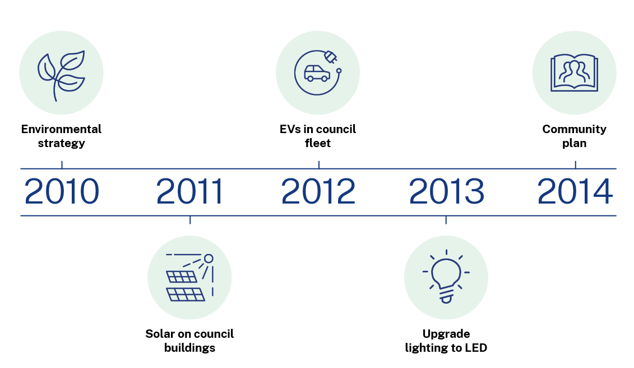
    - Community engagement
In this section of your strategy, your goal is to communicate how the community was engaged, and what processes were applied.
Bring the process to life with as many visual communication techniques as possible. You might like to share surveys, questionnaires, screenshots, charts, graphs or direct quotes from people involved in the process.
You could also expand on this section with local information drawn from other community engagement surveys or data such as percentage of buildings with PV, electric vehicle ownership and charging infrastructure to highlight local ambition and challenges.

Things to consider
Have you set the strategic context – global, national and local – so your reader understands why the strategy is important?
Have you included the most up-to-date science and summaries of global progress?
Have you included a carefully considered vision statement?
Have you incorporated advice on local support and ambition, including your council climate emergency declaration (if declared)?
Have you acknowledged prior council achievements, including operational and collaborative projects to demonstrate you are walking the talk?
Have you brought to life the community engagement process that helped to shape the strategy by featuring quotes from your community, infographics or charts, or reports from specific interest groups such as your local chamber of commerce?
Have you quantified your engagement results and feedback wherever possible?
- Insight
4
  - Emissions sources and targets
Use this section of the strategy to outline your community’s main emitting sectors and help readers to understand the true scale of local emissions. You should aim to use reliable sources of information for your emissions profile. This could be profiles that are compliant with reporting under the Global Protocol for Community-Scale Greenhouse Gas Inventories (‘GPC compliant’), which has been designed to promote best practice greenhouse gas accounting and reporting. The Resilient Sydney dashboard for Greater Sydney councils and the Snapshot tool for regional and rural councils are both reliable resources.
Your outline of the greatest sources of emissions in your community will lead into your Strategy’s strategic priorities. You can communicate this with a simple chart or with icons in an infographic. An example is illustrated below.
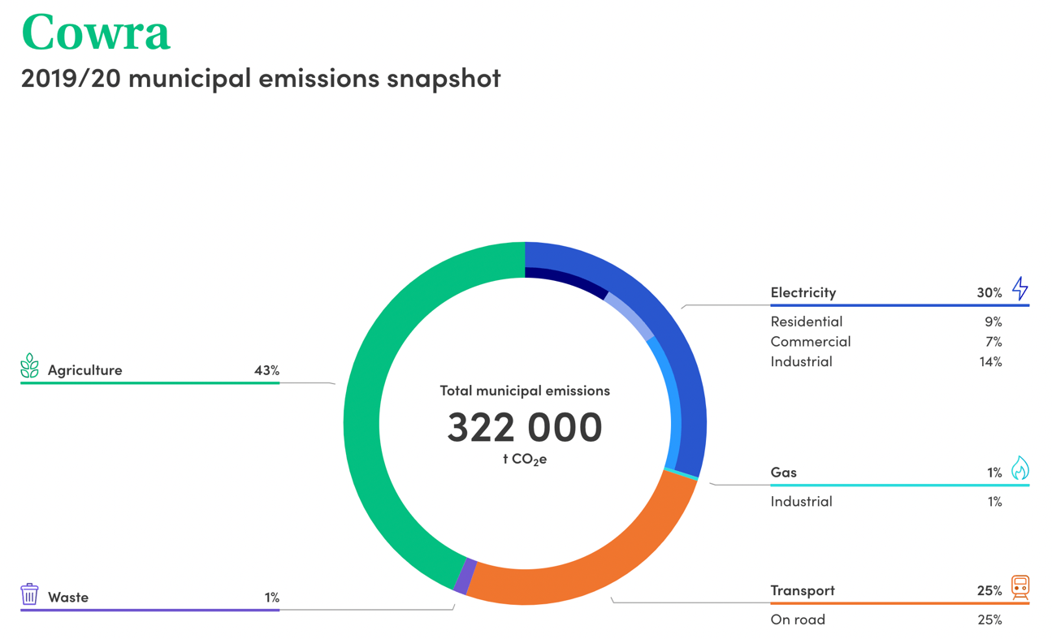
Snapshot community emissions profile for Cowra 2019-20

Council has limited control and influence over many of the community’s emissions sources. Council can advocate and assist the community to implement actions to help reduce emissions, but a cross-sectoral approach is required. This means residents, businesses, industries and other levels of government must collaborate to drive down emissions.

Example infographic display of emissions sources:

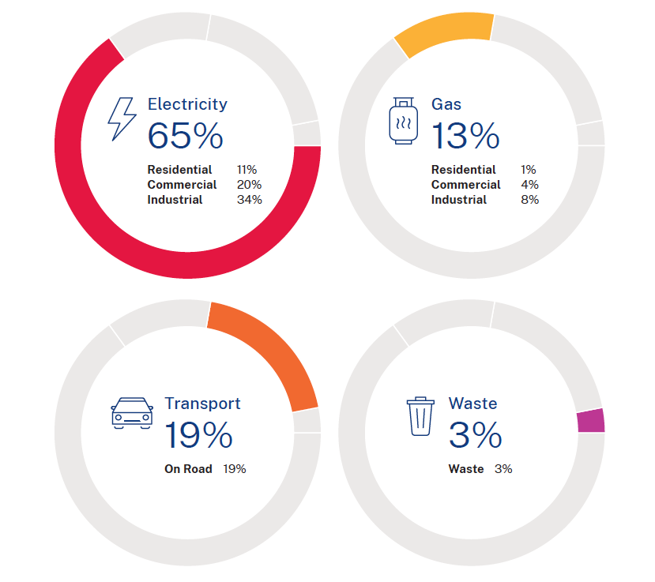

You can use this table below in your strategy to demonstrate the main sources of emissions:

Electricity | Gas | Transport | Waste | Agriculture
% | % | % | % | %
Residential %  Commercial %  Industrial % | Residential %  Commercial %  Industrial % | On road % | Waste % | Agriculture %

You should also consider how emissions are expected to change over time. As we outlined in the Net zero community emissions guide for NSW councils, this can be challenging and may require external expertise, perhaps through a regional collaboration like a joint organisation.
Below is an example of a basic emissions trajectory chart (in this case for the City of Wagga Wagga). The decline in emissions is driven by the decline in electricity emissions as the grid decarbonises.

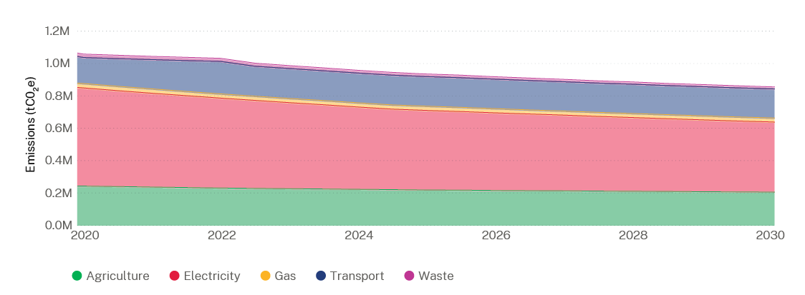

Irrespective of whether you model your future emissions, it is important to consider the factors influencing how they might change over time. The table below outlines some of the main factors to consider. In some cases, you may have access to statistics for the given factors, while in others you may have a qualitative description of the expected trends.

Icon | Factor | Description
 | Population growth/decline | Changes in population will be reflected in increased or decreased energy consumption from housing, commercial activity and transport.
 | Greenfields or infield development | While closely related to population growth, you may have access to good information on upcoming developments through your planning department. If significant, these are worth noting separately to population changes.
 | Economic growth/decline | Historically, economic growth in cities has typically meant increases in emissions. It is technologically possible, however, to decouple economic activity from emissions, such that businesses can thrive while reducing emissions.
 | Changes to mix of industry or agriculture | Emissions intensity depends on the industry, so if there is a change to the mix this will impact on emissions. You might consider how emerging or declining industries may influence your profile. Are certain local industries being incentivised, such as with a new renewable energy zone, or is there a large emissions source being planned like a new airport? Your planning department may be able to assist with this.
 | Electricity grid emissions intensity | The emissions intensity of the grid in NSW will decline as more renewable electricity is fed into the grid.
 | Technology improvements | Emerging technologies provide new opportunities for emissions reductions. Electric vehicles and household batteries are the two primary examples in 2022. As these technologies are refined and adopted, they will become cheaper, which is projected to further accelerate their take-up.
 | Uptake of zero emissions transport | Electric passenger vehicles are projected to achieve cost-parity with internal combustion engine cars from around 2026 to 2027. This is because other countries have set strong EV sales targets, and car manufacturers are responding by planning to phase out fossil fuel powered vehicles.
 | Uptake of renewables | The number of solar installations in NSW continues to increase due to state and local incentives, as well as market forces making onsite renewable energy generation more affordable for households and businesses.
 | Policy environment | The policy environment at state and federal levels can both encourage and hinder emissions reductions.

The Greater Sydney Commission’s 2022 Pathways to Net Zero Emissions report provides a good outline of the drivers impacting emissions for Sydney councils, much of which is also relevant more broadly. Also make sure to review your community strategic plans and NSW regional plans.

- Target
5
  - Rationale for targets
Use this section to outline how and why your community target was chosen. It may align with state or federal targets, with your municipality’s science-based target or with your council’s own target to reduce operational emissions. Regardless of how your target was chosen, be sure to clearly explain the rationale behind it. For more information about science-based targets, read the Net zero community emissions guide for NSW councils. Examples to consider are:
“Net zero greenhouse gas emissions for the community by <2030 / other year>”
“Support the community to reduce greenhouse gas emissions by < XX % > by 2030”
“Encourage our community to reduce greenhouse gas emissions” (no set target but general statement of commitment)
Communicating a community target
Referencing the limits set by a science-based target within your strategy can confirm your target’s objectivity by demonstrating how it is grounded in climate science.
Be clear on the line of accountability in any public discourse. In the past, councils have been criticised for not meeting community-wide targets, often because of the way they framed the target. Unlike an operational or corporate target, it is not council’s responsibility alone to meet the target. It requires support and action at all levels of the community, business and government. Many recent climate emergency action plans have made this differentiation clear and are useful guides. Alternatively, you may like to adapt the text below.
While Council has a critical role to play in reducing emissions and adapting to climate change, it is important to acknowledge that Council is not solely responsible for the municipality achieving the net zero emissions target. Similarly, Council cannot implement the programs in this action plan without community and stakeholder investment. Emissions reductions at this scale will require significant contributions from residents, businesses and industry, and the state and federal governments. It will also require broader societal and structural changes that are beyond Council’s influence.

The programs in this action plan highlight key action areas within Council’s sphere of influence that can significantly reduce emissions in the region. Council will also aim to influence action beyond its control through advocacy and leadership.

Things to consider
Have you included clear baseline data, emissions sources and profiles?
Have you considered the factors that might influence future emissions, including reviewing community strategic plans and NSW regional plans for background information?
Have you acknowledged your sources?
Have you set clear and measurable target(s)?
Have you set clear boundaries around your council’s responsibilities and influence?
- Strategy
6
  - Strategic priorities
Strategic priorities are the high-level focus areas on which your strategy is based, and which support your overall mission. Under each of these strategic priorities, you should aim to identify clear and relevant objectives, each with one or more targets. These will show how you will measure progress, making sure each strategic priority is feasible and can be implemented. Actions to meet your targets will be outlined in Section 3.10 and monitoring of your targets will be outlined in Section 3.11. Take care to keep the number of strategic priorities to a minimum to ensure your strategy has clear, focused and well-considered areas of action. Start with each strategic priority and then follow this with a description of the objectives and measurable targets. Objectives are what you want to achieve within each strategic priority and targets set your ambition for progress that can be measured over time.
Strategic priorities can be based on process (e.g. council leadership or supporting communities) or specific areas of action (e.g. transport or land use planning). Some examples of each are provided below. Note that these examples are not necessarily relevant to your council – you will need to determine your objectives and targets through your analysis in the Insight stage. Just a few example strategic priorities are shown here, but your plan is likely to have more than these, especially for the process-based examples.

Example:

Process-based examples:

Strategic priority 1: Leadership | Strategic priority 2: Supporting communities | Strategic priority 3: Resilience
Council is a leader in net zero action | A thriving net zero community | A resilient and adaptive community
Objective 1.1: reduce electricity consumption  - Target: Install solar and batteries on key Council facilities by 2025  Objective 1.2: transition fleet to EV  - Target: All Council fleet transitioned to EV by 2025 | Objective 2.1: reduce emissions from waste  - Target: Reduce proportion of food and garden organics in residential waste by X% by <year>  - Target: Reduce emissions at landfill A by X% by <year>  Objective 2.2: Reduce transport emissions in the community  - Target: Reduce transport emissions in the community by X% by <year> | Objective 3.1: increase canopy cover  - Target: Council has an urban forest strategy by 2023.  Objective 3.2: embed climate change into Council strategic planning  - Target: Climate change embedded into budget planning process by <year>

Action area-based examples

Strategic priority 1: Transport | Strategic priority 2: Waste | Strategic priority 3: Electricity
Objective 1.1: Increase active transport  - Target: Increase proportion of trips made by active transport by X% by <year>  Objective 1.2: Increase number of EV chargers in the municipality  - Target: Facilitate installation of X EV chargers by <year> | Objective 2.1: Reduce emissions from landfill  - Target: Increase diversion of food organics and garden organics by X% by <year>  - Target: Reduce emissions from landfill by X% by <year> | Objective 3.1: Reduce commercial electricity use  - Target: Reduce commercial electricity use by X% by <year>  Objective 3.2: Improve energy efficiency of new buildings  - Target: High performing building standards for new buildings adopted by <year>

You can use the table below to insert your own strategic priorities. Note that you might like to keep this section simple by omitting the targets at this stage and outlining them instead in your monitoring and evaluation section. However, you should be thinking about relevant targets when developing your objectives and strategic priorities.

Strategic priority 1:  < Title > | Strategic priority 2:  < Title > | Strategic priority 3:  < Title >
Optional description of strategic priority | Optional description of strategic priority | Optional description of strategic priority
Objectives and targets | Objectives and targets | Objectives and targets
Objective 1.1:  - <Target>  - <Target>etc | Objective 2.1:  - <Target>  - <Target>etc | Objective 3.1:  - <Target>  - <Target>etc

In determining your strategic priorities, you should look at the priorities set in other council plans and any relevant council motions. You should also consider the actions you will undertake as part of your strategy. These should be outlined in more detail in the Action section of your strategy, but it is important to be mindful of these when setting strategic priorities. You may also like to involve other areas of your council at this stage to gain buy-in and to capture actions that are already occurring across your council.
You should consider:
- What actions need to be taken in the community to reduce emissions?
- What is the role of other stakeholders in delivering these actions?
- What are the barriers or challenges that may prevent these actions from occurring?
- What is the role of council in accelerating or increasing the uptake of these actions?
- How will the success of the actions be monitored and measured?
- What actions are already planned and how can other parts of council participate in the strategy?
To answer these questions, you might look to data analysis, stakeholder engagement or a combination of both. The Climate Change Mitigation ‘Cheat Sheet’ for Councils and the list of intervention types in the Guide (Section 7.5) can inform your thinking around actions.

Things to consider
What priorities from other council plans, policies and council motions are relevant?
What actions do you plan to undertake to reduce emissions? Please refer to the Guide for information on the types of actions you could take.
Have you grouped actions into strategic priorities (up to 10)?
Have you set clear objectives and targets for each strategic priority that are feasible and relevant to your municipality?
Have you reviewed the strategy section of the Net zero community emissions guide for NSW councils for extra tips and tricks?
Have you used tables, infographics or other charts to make it easy for your readers to digest?
- Action
7
  - Actions
This section builds on the strategic priorities and actions identified in the last section. Taking action is at the heart of your strategy, so these actions should be laid out logically and linked to resources, partnerships or collaborations that may aid implementation. The Action section of your strategy should not be considered an implementation plan, but rather an outline of how the strategic priorities will be delivered. A detailed design and implementation phase will be necessary to determine scope, timeframes and costs required for each action proposed.
When deciding which actions are prioritised in your strategy, consider the following:
- What is the capacity of the action to reduce emissions and boost climate resilience?
- What is within Council’s control and capacity? Can we leverage existing programs, initiatives, and resources?
- What can we learn from actions being taken by other stakeholders or councils?
- Have we received feedback from the community on actions that are impactful and achievable and that address known barriers? Will the action fulfil objectives and progress us towards our targets? Are there important co-benefits associated with this action, such as social, health or employment?
You may like to revisit your strategic priorities after you have prioritised your actions, to make sure they still align.
The table below is an example of how you might display the information on each action. You might like to link each action to an objective, the description of the action, estimated costs or staff resources required, and the timeframe of the action.
Objective | Action description | Investment | Timeframe
1.1 Support transition to EVs | Facilitate installation of electric vehicle charging infrastructure | $  Staff time | Short term
1.2 Support mode shift to alternative transports | Facilitate installation of bicycle and active transport infrastructure | Existing budget | Long term

Action ID | Action description | Investment | Timeframe

Other possible columns your action table could include:
- Council department responsible for the action, such as your planning or economic development teams
- Other policies or plans that the actions may link to (e.g. Council’s transport plan)
- Estimated impact in terms of the amount of CO2e that will potentially be abated by the action if known (high, medium, low)
- The primary impact areas of each action such as human health or natural environment
- The sector, such as transport or stationary energy
- Stakeholders targeted, such as renters, the local business council
- Metric, i.e. the data to be collected for monitoring and evaluation, such as number of charging stations installed. Note, you may prefer to outline this information in the Monitoring & Evaluation component of your strategy.
Where climate or net zero actions are already occurring in the community, you may like to showcase local case studies throughout your strategy (not just in the Action section). For example, you may mention local businesses or community groups that are already reducing community emissions by installing EV charging stations, investing in solar panels on community facilities, or undertaking tree planting:
Sample case study
Council has provided dedicated electric vehicle fast charging bays to boost the uptake of low and zero emissions vehicles.
With the new charging bays in central locations in < place > and < place >, Council hopes to encourage more locals to use electric vehicles and create a welcoming environment for EV users who may visit from out of town. These charging bays are in addition to those already installed at < place >, and < place >.
Council is dedicated to taking positive steps to assist < City / municipality name > to shift to low or net zero emissions transport, and making the changes needed to create a climate resilient community. Council has also demonstrated commitments to community net zero emissions target by introducing electric vehicles into Council fleet, to reduce greenhouse gas emissions and improve air quality.
Things to consider
Are your key actions listed and grouped in a logical way?
Do your actions align with your strategic priorities?
Have you kept your tables simple and easy to understand?
Have you clarified the difference between the roles of council, state and federal government, and the community?
Have you reviewed the Net zero community emissions guide for NSW councils for more information?
Have you noted planned partnerships, collaborations and/or advocacy for specific actions where relevant?
Have you linked the community strategy with actions already occurring at council?
Have you reviewed to ensure this section clearly articulates your council’s role or services for each action?
Have you considered the stakeholders, partners or agencies that may be involved in the actions?
Have you included supporting information for each action, if required, in the Appendix?
- Monitoring
and evaluation
8
  - Monitoring and evaluation
As discussed previously, every objective in your strategy should be allocated one or more targets so that progress can be monitored. The NSW Local Government IP&R Framework recommends that the strategy should identify the:
Baseline: Where are we now?
Target: Where do we want to be?
Timeframe: How will we know when we’ve arrived?
A simple table can list the metrics used to monitor and report on targets. Some examples are provided below.
Link to relevant objective | Target | Metric | Baseline value | Data source
This is the link between the metric and the relevant part of your strategy | This is the measurable change that your council’s actions are aiming to achieve. It should include a timeframe. | This is the metric used to measure progress | This is the current value of the metric | This is where the data is sourced from
Example: Improving energy security | Example:  Increase Solar PV by x% by <year> | Example:  Total solar installations (% of all dwellings) | Y% | Example: Australian PV Institute
Example: Improve mode share of active transport | Example:  Increase active transport by x% by <year> | Example:  % of distance travelled in municipality using active transport (bicycle and walking) | Y% | Example:  Google Environmental Insights Explorer
Example: Reduce emissions from waste | Example:  Reduce proportion of food and garden organics in residential waste by x% by <year> | Example:  % of food and garden organics in residential waste | Y% | Example:  Council waste contractors

There may be more than one action associated with each objective, so it is also important that project monitoring of each action is undertaken (see Section 3.10 Actions and Section 7.7 Measuring success in the Net zero community emissions guide for NSW councils). Monitoring both is key. For example, a significant increase in cycling as a proportion of transport mode may be measured, but if your council can see that only 3 people have downloaded the specially-developed cycling resources, the increase is not as a result of the program. Monitoring of individual actions and the broader target enables the impacts of programs to be properly evaluated.
It is also important to understand if the results observed through your council's monitoring and evaluation are additional to the business-as-usual – in other words that the changes measured would not have occurred without your council's programs. This is where you can link to the outcomes of any emissions trajectory forecasting or analysis of trends carried out as outlined in Section 3.7. You can build your understanding of impacts beyond business-as-usual into the target-setting itself. For example, if the forecasting suggests the number of households with solar PV is likely to increase by 25% as part of the business-as-usual, then your council's target could be adjusted to take this into account. In this case an appropriate target might be a 10% increase in the number of households with solar PV in addition to the increases expected as part of the business-as-usual trajectory (i.e. a 35% increase). See 8.2 Collecting the right data in the Net zero community emissions guide for NSW councils for more information monitoring action impacts.
The Climate Change Mitigation ‘Cheat Sheet’ for Councils included in the Guide gives you some sources of data to consider. You might also look at the monitoring and evaluation case study interview with Sam Kelley from Randwick Council for an example of how this can be done well.

Things to consider
Have you accessed reputable data sources such as the Resilient Sydney Platform or the Climate Snapshot tool to inform the selection of your metrics?
Could your evaluation be undertaken by an independent auditor?
Have you set measurements using indicators determined by your council? And do these metrics link back to strategic objectives?
Have you considered monitoring both your overall targets and the outcomes of particular actions?
Have you presented clear, easy-to-understand monitoring and evaluation methods?
  - Glossary
This glossary is a guide only. You can add or remove words as appropriate. Make sure to spell out acronyms, and ensure definitions are from a reliable source of information. You may also wish to include the glossary at the start of your net zero strategy instead of at the end.

Adaptation: Adapting to climate change is adjusting to current or expected climate change and its effects. Adaptation helps individuals, communities, organisations and natural systems to manage the impacts of climate change. It involves taking practical actions to adjust to the changing climate which protect and build our resilience.
Business-as-usual (BAU): In the context of climate change mitigation, BAU refers to the normal trajectory of the uptake of actions that impact or respond to global warming. Essentially, these are the actions that we expect will occur without additional directed action to reduce emissions or respond to climate change.
Carbon budget: Volume of greenhouse gases that can be emitted into the atmosphere before exceeding dangerous thresholds.
Carbon credit: An instrument that represents ownership of one metric tonne of carbon dioxide equivalent that can be traded, sold or retired. When an organisation uses fewer emissions (credits) than it is allocated, it can trade, sell or hold the credits. Please also see relevant information under carbon offsets below.
Carbon offsets: Offset units are used to compensate for emissions an organisation produces and to bring its carbon footprint down to zero. Offset units are generated by projects that reduce or remove emissions from the atmosphere such as energy efficiency, renewable energy or reforestation.
Carbon sequestration: The long-term storage of carbon in plants, soils, geologic formations, and the ocean.
Circular economy: A system in which all resources are highly valued and remain in the system through reuse, re-purposing and recycling. A circular economy tends to focus on local production.
Climate emergency declaration: This is a response by governments worldwide to the catastrophic climate changes brought about by human activity that poses a dangerous threat to all life on the planet. This declaration is an admission that humanity is in a climate emergency and is a way to set priorities to mitigate and adapt to climate change.
Closed loop principle: This is the process by which a product or material can be used, reused and then turned into new products or materials indefinitely without losing its qualities during the process of recycling or reuse. It can also be converted back into raw materials. For example, an aluminium can may be recycled to create new cans with little material degradation or waste as part of the process.
Community batteries: Community batteries, or “neighbourhood batteries” are larger sized battery units embedded in the network that allow for shared battery storage. Community batteries enable customers to store the excess power generated during the day by their rooftop solar cells for use later in the evening, when demand on the electricity network is higher.
Community emissions: Community emissions are the total sum of emissions produced by a city, region or municipality. This includes emissions associated with all sectors present within a community such as transport, industry, commercial and residential.
CO2e: Also known as ‘carbon dioxide equivalent’, this is a measure used to quantify the emissions associated with various greenhouse gases on the basis of their global warming potential. CO2e was created by the United Nations' Intergovernmental Panel on Climate Change (IPCC) to make the effects of different greenhouse gases comparable because every gas has a different global warming potential.
COP: The Conference of the Parties (COP) is the supreme decision-making body of the United Nations Framework Convention on Climate Change. The COP meets every year, unless the Parties decide otherwise. The first COP meeting was held in Berlin, Germany in March 1995.
Emissions reduction: Reducing the amount of greenhouse gases emitted into the atmosphere from human activities.
Energy efficiency: Using less energy to perform the same task. For example, energy efficient appliances such as refrigerators or air conditioners can perform the exact same function while using less electricity, saving CO2e emissions and money.
Energy security: Relates to how the power system or electricity grid reacts to events that may influence it, including the grid’s capability to react to and recover from events such as faults.
Environmentally Sustainable Design (ESD): Design of buildings and infrastructure that meets the needs of owners, occupants and the environment through high performance, energy and resource efficiency. ESD aims to reduce impacts on the environment in the construction and use of buildings and improve the comfort of the inhabitants.
Environmental Upgrade Agreements (EUAs): Also known as Environmental Upgrade Finance, an EUA is a type of loan that is available to businesses and homeowners to make their properties more sustainable and climate resilient. The funding can be used for a variety of interventions, such as LED lighting upgrades on commercial buildings or the installation of home sprinklers on residential dwellings for bushfire protection. Under these loans, lenders (financial institutions) provide finance to the property owner for the upgrade and the property owner repays the loan through council rates.
Global Protocol for Community-Scale Greenhouse Gas Emissions Inventories (GPC): Created by a partnership of leading sustainability organisations – the World Resources Institute, C40 Cities Climate Leadership Group and ICLEI-Local Governments for Sustainability – the GPC provides a robust framework for accounting and reporting community greenhouse gas emissions. It is a city’s tool to calculate city-wide greenhouse gas emissions and use this inventory to support climate action planning.
Greenhouse gas (GHG) emissions: These are emissions released by the process of consuming fossil fuels and the production of materials. Through the process of the greenhouse effect, these gases remain in our atmosphere and trap the sun’s heat, increasing the temperature of the earth. Greenhouse gases refer to the sum of seven gases that have direct effects on climate change: carbon dioxide (CO2), methane (CH4), nitrous oxide (N2O), chlorofluorocarbons (CFCs), hydrofluorocarbons (HFCs), perfluorocarbons (PFCs), sulphur hexafluoride (SF6) and nitrogen trifluoride (NF3). Data is expressed in CO2 equivalents (CO2e) and refers to gross direct emissions from human activities (OECD 2022).
Intergovernmental Panel on Climate Change (IPCC): This body was established by the United Nations to provide policymakers with regular scientific assessments on climate change and its implications and future risks. As an authoritative global body, the IPCC also suggests various adaptation and mitigation options to reduce the impacts of climate change.
Microgrid: A microgrid is an independent power network that uses local, distributed energy resources to provide grid backup or off-grid power to meet local electricity needs. At the most basic level, microgrids are “micro” (small) and offer a “grid”, or an interconnecting system of links.
Mitigation: Climate change mitigation reduces or eliminates the causes of climate change. This includes actions that reduce emissions, such as improving the energy efficiency of buildings or switching to electric vehicles, as well as efforts to capture and sequester carbon from the atmosphere.
The Paris Climate Conference and the Paris Agreement: Approved by 196 parties, including the European Union, at COP21 in Paris in 2016, the Paris Agreement refers to a set of goals to reduce emissions with the preferred goal of limiting global warming to 1.5°C compared to pre-industrial levels, and the ultimate goal of limiting global warming to 2°C.
Power Purchase Agreement (PPA): A PPA is an agreement between an independent power generator and a purchaser for the supply and sale of energy. Usually, this will be between a large organisation, such as a city council or a company, and a renewable energy electricity supplier such as a local wind farm. PPAs ensure that all the electricity purchased comes from a specific source at an agreed price.
Renewable energy: This energy is collected from renewable sources that are naturally replenished or infinite. These sources include sunlight, wind, water and geothermal heat. Energy can be harnessed from these on a small (residential), medium (community) or large (commercial) scale to provide emissions-free energy.
Resilience: The capacity of an asset, individual or community to absorb the acute and built-up shocks and stresses associated with climate change. Resilience also includes our ability to ‘bounce back’ or respond to climate change.
Solar PV: Solar photovoltaics are the rooftop solar panels on homes and businesses, producing electricity directly from the sun.
United Nations Framework Convention on Climate Change (UNFCCC): An international environmental body formed as a result of a treaty adopted in 1992.
The UNFCCC is the body responsible for organising global consensus on climate change related issues. The UNFCCC convenes an annual conference, referred to as the Conference of the Parties (COP).
Virtual Power Plant (VPP): This is a network of decentralised, power generating units such as wind farms, solar parks and energy storage solutions that can be used to supply electricity either back to a grid or directly to a community. Virtual power plants allow renewable energy to be injected into the grid with lightning speed to address frequency and voltage imbalances, local disruptions or disturbances and stabilise the network.

  - Appendices
The Appendix section contains any information that is supplementary to your strategy. This could be data, tables, images or lists. Some examples of what you could have in this section include:
- more detailed information on monitoring performance
- community engagement activities that took place, and who attended
- lists and details of past or current council net zero emissions initiatives and activities
- ideas on how to community members can get involved with details of projects, workshops, groups, newsletters and more
- useful tools, like energy use calculators, that can support emissions reductions.

